**Mentors and Notable Students**

After studying with **J. J. Thomson** at the Cavendish Laboratory at Cambridge University, Rutherford became a professor and chair of the Physics Department at McGill University in Montreal, Canada.

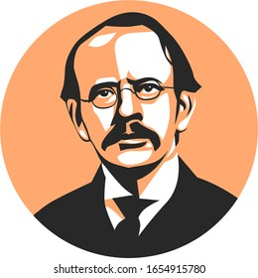

**One of the mentors**

**Colleague**

J. J. Thomson

**Sir Joseph John Thomson**  was a British [physicist](https://en.wikipedia.org/wiki/Physicist) and [Nobel Laureate in Physics](https://en.wikipedia.org/wiki/Nobel_Prize_in_Physics), credited with the discovery of the [***electron***](https://en.wikipedia.org/wiki/Electron), the first [subatomic particle](https://en.wikipedia.org/wiki/Subatomic_particle) to be discovered and also credited with the discovery of ***Isotopes***.

**James Chadwick** as we know who helped discovered proton and theorized about existence of protons was a notable student of Ernest Rutherford.

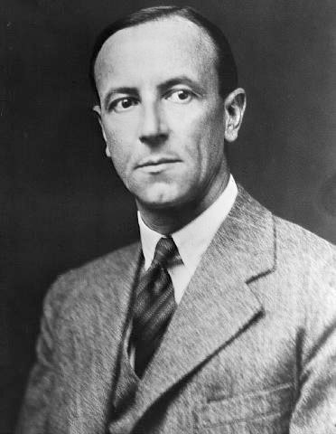

Rutherford's speech touched on the 1932 work of his students **John Cockcroft** and **Ernest Walton** in "splitting" lithium into alpha particles by bombardment with protons from a particle accelerator they had constructed.

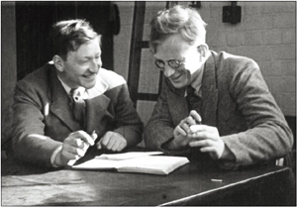

Rutherford had an enormous influence on the field of nuclear physics and **mentored** many future Nobel Prize winners and prominent scientists, including [**Niels Bohr**](http://atomicheritage.org/profile/niels-bohr) and [**Otto Hahn**](http://atomicheritage.org/profile/otto-hahn)**.**

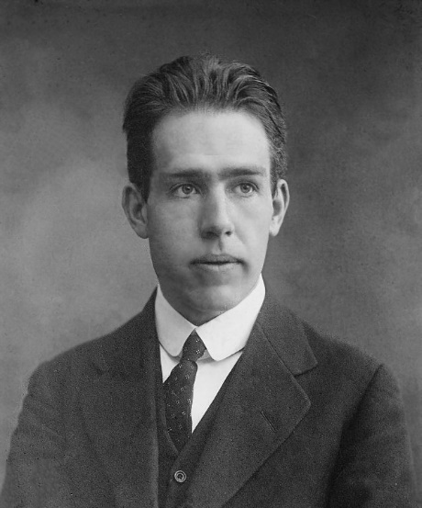

[**Niels Bohr**](http://atomicheritage.org/profile/niels-bohr)

**Bohr** was the first to discover ***that electrons travel in separate orbits around the nucleus*** and that ***the number of electrons in the outer orbit determines the properties of an element.*** The chemical element bohrium (Bh), No. 107 on the periodic table of elements, is named for him

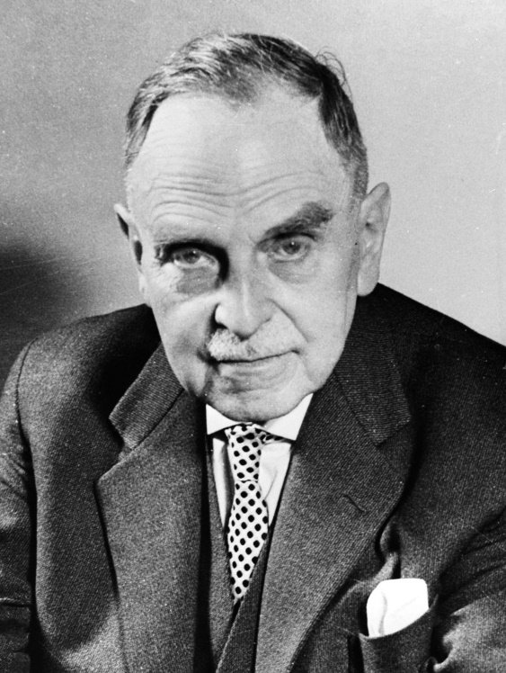

**Otto Hahn**

**Hahn** discovered ***the fission of uranium and thorium*** in medium heavy atomic nuclei and his first work on these subjects appeared on 6th January and 10th February, 1939, in Naturwissenschaften. He also discovered ***Radioactive Elements***

Rutherford Students or people who he guided

1. **James Chadwick**
2. **John Cockcroft**
3. **Ernest Walton**
4. [**Niels Bohr**](http://atomicheritage.org/profile/niels-bohr)
5. **Otto Hahn**